Kịch bản: 10 client, chọn ngẫu nhiên 4 client mỗi round

Alpha = 1

FedAvg

FINAL RESULTS:

Test: commun_round: 10 | global_acc: 0.3974 | global_pre: 0.9143035999999998 | global_rec: 0.3974 | global_f1s: 0.43205629923084016

'accuracy': [(0, 0.0986), (1, 0.1404), (2, 0.1763), (3, 0.2762), (4, 0.2945), (5, 0.3414), (6, 0.3808), (7, 0.3498), (8, 0.3534), (9, 0.3959), (10, 0.3974)]

FedImp

FINAL RESULTS:

Test: commun_round: 10 | global_acc: 0.397 | global_pre: 0.7363836 | global_rec: 0.397 | global_f1s: 0.4426013494127932

'accuracy': [(0, 0.1044), (1, 0.1267), (2, 0.2457), (3, 0.2141), (4, 0.3168), (5, 0.3234), (6, 0.3799), (7, 0.3483), (8, 0.3789), (9, 0.3305), (10, 0.397)]

FedCvM

FINAL RESULTS:

Test: commun_round: 10 | global_acc: 0.4345 | global_pre: 0.6490300999999999 | global_rec: 0.4345 | global_f1s: 0.4619842173844755

'accuracy': [(0, 0.0909), (1, 0.1326), (2, 0.2174), (3, 0.2847), (4, 0.3505), (5, 0.3551), (6, 0.3885), (7, 0.3766), (8, 0.3691), (9, 0.3543), (10, 0.4345)]

**FedWL2**

Test: commun_round: 10 | global_acc: 0.5243

[(0, 0.1004), (1, 0.1214), (2, 0.2977), (3, 0.3316), (4, 0.3562), (5, 0.4072), (6, 0.4362), (7, 0.4436), (8, 0.4865), (9, 0.4931), (10, 0.5243)]

**Alpha = 0.5, 50 round**

**FedAvg**

Test: commun_round: 50 | global_acc: 0.4096 | global_pre: 1.0 | global_rec: 0.4096 | global_f1s: 0.4440105775219694

'accuracy': [(0, 0.0891), (1, 0.1), (2, 0.1124), (3, 0.179), (4, 0.1901), (5, 0.1414), (6, 0.216), (7, 0.1923), (8, 0.2359), (9, 0.2614), (10, 0.2983), (11, 0.2262), (12, 0.2288), (13, 0.2316), (14, 0.2664), (15, 0.244), (16, 0.2646), (17, 0.2862), (18, 0.3187), (19, 0.2588), (20, 0.3533), (21, 0.2421), (22, 0.3117), (23, 0.2843), (24, 0.3093), (25, 0.3724), (26, 0.3384), (27, 0.3379), (28, 0.3196), (29, 0.2886), (30, 0.4096), (31, 0.3149), (32, 0.2778), (33, 0.2717), (34, 0.3063), (35, 0.3927), (36, 0.4002), (37, 0.383), (38, 0.3463), (39, 0.3126), (40, 0.3456), (41, 0.3443), (42, 0.3799), (43, 0.3554), (44, 0.3129), (45, 0.3687), (46, 0.3411), (47, 0.3394), (48, 0.4092), (49, 0.3584), (50, 0.35)]

**FedCvM**

Test: commun_round: 50 | global_acc: 0.4257 | global_pre: 0.9648853999999999 | global_rec: 0.4257 | global_f1s: 0.4674360150245102

'accuracy': [(0, 0.1104), (1, 0.1062), (2, 0.202), (3, 0.2503), (4, 0.2885), (5, 0.3039), (6, 0.3064), (7, 0.2793), (8, 0.3011), (9, 0.2862), (10, 0.286), (11, 0.3101), (12, 0.31), (13, 0.3412), (14, 0.2887), (15, 0.3658), (16, 0.3268), (17, 0.3297), (18, 0.3722), (19, 0.3699), (20, 0.3341), (21, 0.3838), (22, 0.3607), (23, 0.3818), (24, 0.3477), (25, 0.3667), (26, 0.382), (27, 0.3165), (28, 0.4168), (29, 0.3336), (30, 0.3678), (31, 0.3978), (32, 0.394), (33, 0.3939), (34, 0.4123), (35, 0.4113), (36, 0.4257), (37, 0.4042), (38, 0.4156), (39, 0.4115), (40, 0.3391), (41, 0.4168), (42, 0.3676), (43, 0.4073), (44, 0.4166), (45, 0.4178), (46, 0.362), (47, 0.4255), (48, 0.3952), (49, 0.4231), (50, 0.4231)]

**FedImp**

Test: commun_round: 50 | global_acc: 0.4913 | global_pre: 0.9774328 | global_rec: 0.4913 | global_f1s: 0.5167415046577375

'accuracy': [(0, 0.101), (1, 0.1533), (2, 0.1744), (3, 0.2881), (4, 0.3099), (5, 0.3078), (6, 0.3434), (7, 0.3683), (8, 0.3733), (9, 0.3326), (10, 0.4365), (11, 0.3924), (12, 0.4276), (13, 0.351), (14, 0.395), (15, 0.4643), (16, 0.4525), (17, 0.4163), (18, 0.3447), (19, 0.4075), (20, 0.4442), (21, 0.4571), (22, 0.466), (23, 0.4649), (24, 0.3988), (25, 0.3973), (26, 0.416), (27, 0.4445), (28, 0.482), (29, 0.4659), (30, 0.4762), (31, 0.463), (32, 0.4231), (33, 0.4792), (34, 0.4778), (35, 0.4539), (36, 0.4913), (37, 0.4864), (38, 0.4829), (39, 0.4459), (40, 0.4424), (41, 0.4489), (42, 0.4015), (43, 0.4436), (44, 0.487), (45, 0.487), (46, 0.487), (47, 0.487), (48, 0.487), (49, 0.487), (50, 0.487)]

FedWL2

Test: commun_round: 50 | global_acc: 0.661

[(0, 0.0999), (1, 0.1216), (2, 0.1137), (3, 0.2699), (4, 0.211), (5, 0.3343), (6, 0.3531), (7, 0.4274), (8, 0.4424), (9, 0.4673), (10, 0.4858), (11, 0.4978), (12, 0.4195), (13, 0.509), (14, 0.5122), (15, 0.5466), (16, 0.5521), (17, 0.5455), (18, 0.4978), (19, 0.503), (20, 0.5508), (21, 0.5417), (22, 0.4976), (23, 0.5453), (24, 0.5699), (25, 0.5807), (26, 0.5869), (27, 0.5735), (28, 0.5968), (29, 0.6071), (30, 0.5807), (31, 0.6047), (32, 0.5984), (33, 0.5876), (34, 0.6116), (35, 0.5808), (36, 0.6184), (37, 0.5818), (38, 0.615), (39, 0.6271), (40, 0.5339), (41, 0.6117), (42, 0.5947), (43, 0.6118), (44, 0.6378), (45, 0.6452), (46, 0.661), (47, 0.621), (48, 0.6391), (49, 0.6122), (50, 0.6194)]

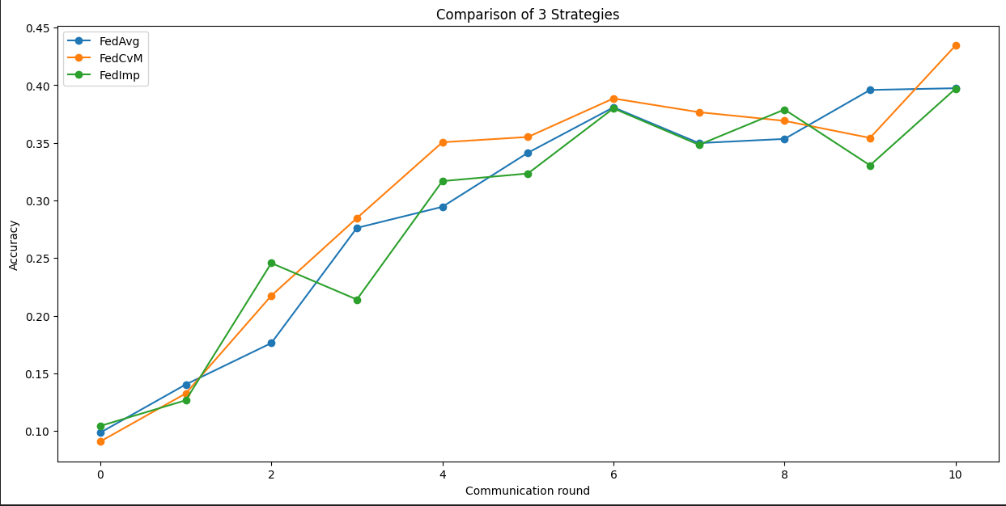

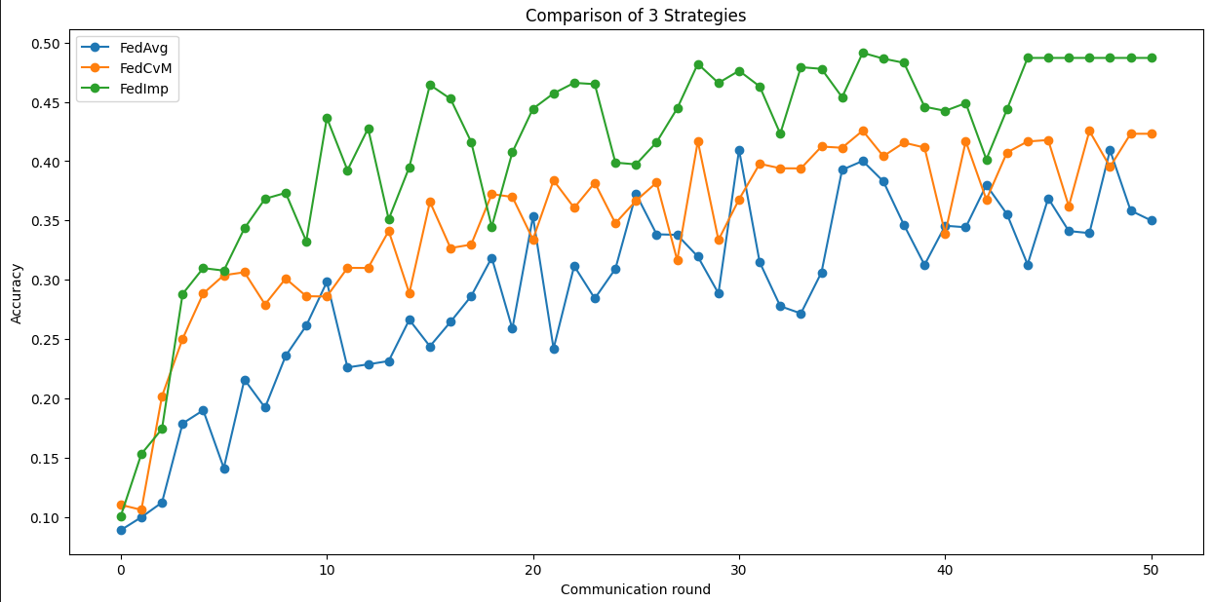

20 client, chon 6

Alpha = 0,1, lr = 0.001

50 rounds

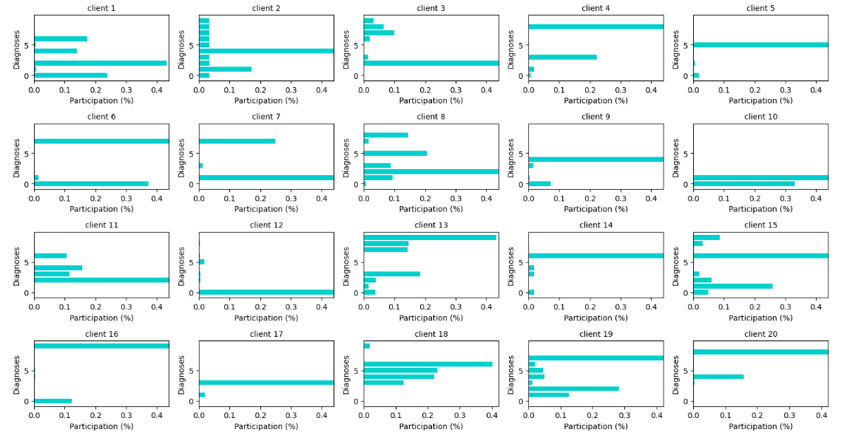

FedAvg

[(0, 0.0996), (1, 0.1008), (2, 0.1), (3, 0.1), (4, 0.1171), (5, 0.1069), (6, 0.1241), (7, 0.1415), (8, 0.175), (9, 0.1191), (10, 0.1149), (11, 0.1196), (12, 0.1548), (13, 0.1666), (14, 0.157), (15, 0.1865), (16, 0.1567), (17, 0.1594), (18, 0.118), (19, 0.1486), (20, 0.1267), (21, 0.1387), (22, 0.1507), (23, 0.2033), (24, 0.1776), (25, 0.191), (26, 0.2572), (27, 0.2244), (28, 0.2536), (29, 0.2107), (30, 0.1808), (31, 0.2509), (32, 0.1961), (33, 0.2542), (34, 0.2888), (35, 0.187), (36, 0.2121), (37, 0.1953), (38, 0.2362), (39, 0.2254), (40, 0.1701), (41, 0.2575), (42, 0.1687), (43, 0.2218), (44, 0.193), (45, 0.2824), (46, 0.219), (47, 0.2331), (48, 0.2498), (49, 0.2608), (50, 0.2513)]

FedWL2

[(0, 0.0991), (1, 0.1), (2, 0.1), (3, 0.1324), (4, 0.1002), (5, 0.1), (6, 0.1001), (7, 0.1), (8, 0.1186), (9, 0.1652), (10, 0.1577), (11, 0.1722), (12, 0.1552), (13, 0.1222), (14, 0.1653), (15, 0.1043), (16, 0.1001), (17, 0.1719), (18, 0.1448), (19, 0.154), (20, 0.1852), (21, 0.1726), (22, 0.2045), (23, 0.1863), (24, 0.1167), (25, 0.1544), (26, 0.2183), (27, 0.1673), (28, 0.1977), (29, 0.2045), (30, 0.1776), (31, 0.1536), (32, 0.1505), (33, 0.2048), (34, 0.1673), (35, 0.2108), (36, 0.2538), (37, 0.2216), (38, 0.2609), (39, 0.2122), (40, 0.2664), (41, 0.2567), (42, 0.2401), (43, 0.282), (44, 0.2834), (45, 0.3021), (46, 0.2634), (47, 0.243), (48, 0.3008), (49, 0.2738), (50, 0.3233)]

Alpha = 10

FedAvg

Test: commun_round: 50 | global_acc: 0.6702

[(0, 0.0834), (1, 0.2267), (2, 0.2734), (3, 0.3169), (4, 0.3453), (5, 0.3676), (6, 0.3944), (7, 0.4393), (8, 0.4535), (9, 0.4804), (10, 0.4739), (11, 0.4939), (12, 0.5058), (13, 0.5061), (14, 0.537), (15, 0.5273), (16, 0.5472), (17, 0.5521), (18, 0.5596), (19, 0.5581), (20, 0.5597), (21, 0.573), (22, 0.5813), (23, 0.5776), (24, 0.5937), (25, 0.5984), (26, 0.5928), (27, 0.6067), (28, 0.6169), (29, 0.6154), (30, 0.6188), (31, 0.6149), (32, 0.6307), (33, 0.6324), (34, 0.6348), (35, 0.6411), (36, 0.6373), (37, 0.6416), (38, 0.649), (39, 0.6537), (40, 0.6393), (41, 0.646), (42, 0.6512), (43, 0.6604), (44, 0.6589), (45, 0.6678), (46, 0.6688), (47, 0.6702), (48, 0.6681), (49, 0.6687), (50, 0.6594)]

FedWL2

[(0, 0.0987), (1, 0.1558), (2, 0.2965), (3, 0.342), (4, 0.3844), (5, 0.4055), (6, 0.4302), (7, 0.448), (8, 0.4601), (9, 0.4869), (10, 0.4866), (11, 0.5104), (12, 0.5311), (13, 0.5354), (14, 0.5484), (15, 0.5527), (16, 0.5705), (17, 0.5595), (18, 0.5811), (19, 0.5937), (20, 0.5909), (21, 0.5929), (22, 0.5864), (23, 0.6123), (24, 0.6105), (25, 0.6186), (26, 0.6221), (27, 0.6281), (28, 0.6285), (29, 0.6384), (30, 0.6389), (31, 0.6424), (32, 0.6417), (33, 0.644), (34, 0.6535), (35, 0.6605), (36, 0.6558), (37, 0.6573), (38, 0.663), (39, 0.6583), (40, 0.66), (41, 0.6725), (42, 0.6712), (43, 0.6764), (44, 0.6763), (45, 0.6689), (46, 0.6757), (47, 0.6754), (48, 0.6718), (49, 0.6819), (50, 0.6845)]

Fix chon client.

0: 6

1: ['2', '1', '4']

2: ['0', '1', '8']

3: ['3', '8', '2']

4: ['3', '4', '1']

5: ['9', '4', '5']

6: ['9', '1', '7']

7: ['5', '2', '6']

8: ['3', '5', '6']

9: ['7', '5', '4']

10: ['9', '0', '6']

50:

Alpha = 1, 10 client chon 3

FedAvg

[(0, 0.0998), (1, 0.1682), (2, 0.2965), (3, 0.3718), (4, 0.4233), (5, 0.392), (6, 0.3432), (7, 0.4439), (8, 0.5039), (9, 0.4723), (10, 0.3905), (11, 0.4109), (12, 0.5189), (13, 0.4388), (14, 0.5103), (15, 0.505), (16, 0.59), (17, 0.562), (18, 0.5236), (19, 0.5545), (20, 0.557), (21, 0.5401), (22, 0.5211), (23, 0.5718), (24, 0.5461), (25, 0.5889), (26, 0.5601), (27, 0.6182), (28, 0.5559), (29, 0.6244), (30, 0.6081), (31, 0.6075), (32, 0.5648), (33, 0.5073), (34, 0.5776), (35, 0.5589), (36, 0.5905), (37, 0.491), (38, 0.5641), (39, 0.625), (40, 0.5884), (41, 0.62), (42, 0.6477), (43, 0.5879), (44, 0.6349), (45, 0.6169), (46, 0.6491), (47, 0.6441), (48, 0.614), (49, 0.6296), (50, 0.5881), (51, 0.6026), (52, 0.5785), (53, 0.5385), (54, 0.5983), (55, 0.5949), (56, 0.5778), (57, 0.4808), (58, 0.5677), (59, 0.6366), (60, 0.5448), (61, 0.5615), (62, 0.5071), (63, 0.4858), (64, 0.6266), (65, 0.617), (66, 0.6195), (67, 0.6282), (68, 0.6399), (69, 0.5741), (70, 0.615), (71, 0.6246), (72, 0.6376), (73, 0.6306), (74, 0.624), (75, 0.5561), (76, 0.6196), (77, 0.6304), (78, 0.6307), (79, 0.6236), (80, 0.6316), (81, 0.6476), (82, 0.6103), (83, 0.5396), (84, 0.5743), (85, 0.5927), (86, 0.6242), (87, 0.6078), (88, 0.6263), (89, 0.6464), (90, 0.6183), (91, 0.6058), (92, 0.6058), (93, 0.6058), (94, 0.6058), (95, 0.6058), (96, 0.6058), (97, 0.6058), (98, 0.6058), (99, 0.6058), (100, 0.6058)]

Loss [(0, 2.303068), (1, 2.2093685), (2, 1.9783031), (3, 2.053684), (4, 1.5303288), (5, 1.6299505), (6, 1.9439061), (7, 1.454582), (8, 1.3661835), (9, 1.403341), (10, 1.8764349), (11, 1.7955785), (12, 1.3082807), (13, 1.7250191), (14, 1.3474826), (15, 1.4343778), (16, 1.1815836), (17, 1.2330707), (18, 1.3879021), (19, 1.338922), (20, 1.2812579), (21, 1.4772004), (22, 1.898186), (23, 1.2361393), (24, 1.3991821), (25, 1.2261528), (26, 1.3165804), (27, 1.097694), (28, 1.4287801), (29, 1.1101558), (30, 1.2606814), (31, 1.2217528), (32, 1.4344476), (33, 1.8008133), (34, 1.3581991), (35, 1.6785512), (36, 1.4295446), (37, 1.8722627), (38, 1.3257928), (39, 1.1539482), (40, 1.4268471), (41, 1.1777377), (42, 1.1108668), (43, 1.471705), (44, 1.1505048), (45, 1.24096), (46, 1.15797), (47, 1.1478161), (48, 1.3197948), (49, 1.2399361), (50, 1.4257218), (51, 1.3988256), (52, 1.5070877), (53, 1.5166444), (54, 1.4202365), (55, 1.5634261), (56, 1.5369458), (57, 2.0704844), (58, 1.6789578), (59, 1.1657764), (60, 1.6839073), (61, 1.6522667), (62, 2.1365573), (63, 1.9370551), (64, 1.215028), (65, 1.3191438), (66, 1.4166012), (67, 1.3347522), (68, 1.2794795), (69, 1.7704943), (70, 1.4668835), (71, 1.2498899), (72, 1.3422221), (73, 1.3978063), (74, 1.3606168), (75, 1.7494719), (76, 1.3207307), (77, 1.3402529), (78, 1.4218735), (79, 1.4505419), (80, 1.4385387), (81, 1.3385744), (82, 1.5225346), (83, 1.7758586), (84, 1.621691), (85, 1.5820938), (86, 1.3998183), (87, 1.5206479), (88, 1.4006696), (89, 1.5040344), (90, 1.3974866), (91, 1.9440316), (92, 1.9440316), (93, 1.9440316), (94, 1.9440316), (95, 1.9440316), (96, 1.9440316), (97, 1.9440316), (98, 1.9440316), (99, 1.9440316), (100, 1.9440316)]

FedWL2

[(0, 0.1), (1, 0.128), (2, 0.2892), (3, 0.3255), (4, 0.3845), (5, 0.3672), (6, 0.4503), (7, 0.4783), (8, 0.4888), (9, 0.4342), (10, 0.4445), (11, 0.4683), (12, 0.4791), (13, 0.5231), (14, 0.4958), (15, 0.4757), (16, 0.572), (17, 0.5226), (18, 0.6082), (19, 0.5541), (20, 0.6163), (21, 0.5347), (22, 0.4914), (23, 0.6189), (24, 0.6016), (25, 0.5954), (26, 0.5987), (27, 0.5889), (28, 0.6185), (29, 0.627), (30, 0.6145), (31, 0.6227), (32, 0.6002), (33, 0.5561), (34, 0.628), (35, 0.6368), (36, 0.6396), (37, 0.6174), (38, 0.6172), (39, 0.6193), (40, 0.6088), (41, 0.6169), (42, 0.6458), (43, 0.6123), (44, 0.6251), (45, 0.5975), (46, 0.6362), (47, 0.6355), (48, 0.6401), (49, 0.6094), (50, 0.5892), (51, 0.6035), (52, 0.598), (53, 0.6323), (54, 0.627), (55, 0.6226), (56, 0.6067), (57, 0.5915), (58, 0.6029), (59, 0.6194), (60, 0.6326), (61, 0.6542), (62, 0.6362), (63, 0.5793), (64, 0.6007), (65, 0.6246), (66, 0.6163), (67, 0.617), (68, 0.6341), (69, 0.5875), (70, 0.6225), (71, 0.63), (72, 0.6319), (73, 0.6125), (74, 0.6396), (75, 0.607), (76, 0.6183), (77, 0.6302), (78, 0.629), (79, 0.6268), (80, 0.6202), (81, 0.6398), (82, 0.6377), (83, 0.6202), (84, 0.5919), (85, 0.6117), (86, 0.6306), (87, 0.6268), (88, 0.6162), (89, 0.6335), (90, 0.6411), (91, 0.6355), (92, 0.6151), (93, 0.6156), (94, 0.6232), (95, 0.5821), (96, 0.6123), (97, 0.6124), (98, 0.6124), (99, 0.6124), (100, 0.6124)]

Loss [(0, 2.3041203), (1, 2.2072034), (2, 1.8828434), (3, 1.9987493), (4, 1.619917), (5, 1.6226382), (6, 1.4580644), (7, 1.4198856), (8, 1.4112903), (9, 1.5173732), (10, 1.4674102), (11, 1.4937266), (12, 1.4148014), (13, 1.3050885), (14, 1.3864689), (15, 1.5011351), (16, 1.1900669), (17, 1.3169929), (18, 1.0773377), (19, 1.2490689), (20, 1.0764643), (21, 1.3434073), (22, 1.4692696), (23, 1.0856), (24, 1.1746718), (25, 1.1960144), (26, 1.2525662), (27, 1.1724298), (28, 1.1167283), (29, 1.0544533), (30, 1.1245843), (31, 1.1288778), (32, 1.1910609), (33, 1.3213904), (34, 1.0650165), (35, 1.0675173), (36, 1.062165), (37, 1.161314), (38, 1.1531383), (39, 1.1517425), (40, 1.2060955), (41, 1.180303), (42, 1.1119914), (43, 1.1741544), (44, 1.2038021), (45, 1.3030392), (46, 1.1836605), (47, 1.1432151), (48, 1.1234587), (49, 1.2661986), (50, 1.3824035), (51, 1.2598559), (52, 1.3079188), (53, 1.1568142), (54, 1.2136207), (55, 1.2588503), (56, 1.3561002), (57, 1.3344765), (58, 1.2862865), (59, 1.2867355), (60, 1.1753143), (61, 1.1398553), (62, 1.2438724), (63, 1.5724355), (64, 1.3370893), (65, 1.2951269), (66, 1.4220697), (67, 1.4298949), (68, 1.3875952), (69, 1.4644883), (70, 1.4976066), (71, 1.1908847), (72, 1.2863381), (73, 1.6464134), (74, 1.4110318), (75, 1.3961672), (76, 1.3418875), (77, 1.3741797), (78, 1.4882867), (79, 1.2753289), (80, 1.4228358), (81, 1.3938615), (82, 1.3641965), (83, 1.4788738), (84, 1.502766), (85, 1.5298632), (86, 1.3412933), (87, 1.3909297), (88, 1.3940363), (89, 1.3338232), (90, 1.481605), (91, 1.4093645), (92, 1.4229778), (93, 1.5766363), (94, 1.4515594), (95, 1.6296105), (96, 1.3774023), (97, 1.4807801), (98, 1.4807801), (99, 1.4807801), (100, 1.4807801)]

FedImp

[(0, 0.0917), (1, 0.2317), (2, 0.2806), (3, 0.3498), (4, 0.3788), (5, 0.3989), (6, 0.4156), (7, 0.4505), (8, 0.4769), (9, 0.4567), (10, 0.3978), (11, 0.444), (12, 0.4925), (13, 0.4645), (14, 0.4905), (15, 0.5039), (16, 0.5579), (17, 0.5334), (18, 0.5571), (19, 0.5588), (20, 0.5955), (21, 0.5448), (22, 0.5181), (23, 0.5875), (24, 0.5802), (25, 0.5838), (26, 0.5835), (27, 0.6066), (28, 0.5753), (29, 0.6134), (30, 0.6081), (31, 0.5933), (32, 0.5882), (33, 0.5035), (34, 0.5561), (35, 0.5507), (36, 0.555), (37, 0.5004), (38, 0.5806), (39, 0.6107), (40, 0.5797), (41, 0.6133), (42, 0.655), (43, 0.5946), (44, 0.6179), (45, 0.5989), (46, 0.6385), (47, 0.6063), (48, 0.6162), (49, 0.6189), (50, 0.5885), (51, 0.5935), (52, 0.5747), (53, 0.548), (54, 0.6226), (55, 0.6007), (56, 0.5561), (57, 0.5046), (58, 0.577), (59, 0.6264), (60, 0.5585), (61, 0.5768), (62, 0.5326), (63, 0.4787), (64, 0.6216), (65, 0.6105), (66, 0.6181), (67, 0.6228), (68, 0.6342), (69, 0.567), (70, 0.6061), (71, 0.5975), (72, 0.6311), (73, 0.6286), (74, 0.6162), (75, 0.558), (76, 0.6156), (77, 0.6057), (78, 0.6404), (79, 0.6084), (80, 0.6058), (81, 0.6206), (82, 0.6204), (83, 0.5994), (84, 0.5689), (85, 0.6104), (86, 0.6104), (87, 0.5944), (88, 0.6041), (89, 0.6477), (90, 0.6207), (91, 0.5977), (92, 0.6057), (93, 0.6207), (94, 0.6087), (95, 0.5511), (96, 0.5796), (97, 0.6099), (98, 0.5653), (99, 0.616), (100, 0.5713)]

Loss [(0, 2.3027153), (1, 2.2083797), (2, 1.9701996), (3, 2.0394886), (4, 1.6124561), (5, 1.5784264), (6, 1.6062337), (7, 1.4699422), (8, 1.4258293), (9, 1.4378494), (10, 1.7949898), (11, 1.6866777), (12, 1.3861152), (13, 1.5899024), (14, 1.3857932), (15, 1.5361711), (16, 1.2666776), (17, 1.3641495), (18, 1.237484), (19, 1.3519033), (20, 1.15028), (21, 1.5183979), (22, 1.7745131), (23, 1.2073574), (24, 1.2825291), (25, 1.254535), (26, 1.2234674), (27, 1.1896193), (28, 1.3979226), (29, 1.1616603), (30, 1.2969433), (31, 1.2189409), (32, 1.3340774), (33, 1.7287686), (34, 1.3967246), (35, 1.5225133), (36, 1.4638357), (37, 1.8830829), (38, 1.2959003), (39, 1.2104155), (40, 1.5309256), (41, 1.1898301), (42, 1.0694822), (43, 1.2974092), (44, 1.3138558), (45, 1.3062141), (46, 1.1895545), (47, 1.2456944), (48, 1.3152382), (49, 1.2944735), (50, 1.4089377), (51, 1.4467695), (52, 1.4140347), (53, 1.4831959), (54, 1.2452914), (55, 1.3921674), (56, 1.8677657), (57, 2.0727122), (58, 1.7881477), (59, 1.2540604), (60, 1.5472145), (61, 1.6065587), (62, 1.9899251), (63, 2.0582047), (64, 1.3218154), (65, 1.4723871), (66, 1.45759), (67, 1.4039719), (68, 1.5638871), (69, 1.7654605), (70, 1.5015398), (71, 1.444333), (72, 1.3434025), (73, 1.50738), (74, 1.5410894), (75, 1.6418668), (76, 1.3297297), (77, 1.4568106), (78, 1.4076824), (79, 1.3211187), (80, 1.5080338), (81, 1.5029386), (82, 1.4899732), (83, 1.5627222), (84, 1.5861262), (85, 1.6160016), (86, 1.5308459), (87, 1.6774201), (88, 1.5886576), (89, 1.3766979), (90, 1.5643213), (91, 1.6567976), (92, 1.6887192), (93, 1.6621042), (94, 1.6668422), (95, 2.4926648), (96, 1.5286134), (97, 1.5062561), (98, 1.6856809), (99, 1.4737601), (100, 1.8261982)]

Alpha = 10, ~100 round

FedAvg

[(0, 0.1), (1, 0.2166), (2, 0.3419), (3, 0.4278), (4, 0.4743), (5, 0.4975), (6, 0.5062), (7, 0.54), (8, 0.5692), (9, 0.5663), (10, 0.5872), (11, 0.5985), (12, 0.6018), (13, 0.6055), (14, 0.6107), (15, 0.6203), (16, 0.6326), (17, 0.6516), (18, 0.6385), (19, 0.6231), (20, 0.6372), (21, 0.6562), (22, 0.6483), (23, 0.6459), (24, 0.6595), (25, 0.6695), (26, 0.6643), (27, 0.662), (28, 0.6554), (29, 0.6458), (30, 0.6771), (31, 0.6613), (32, 0.6713), (33, 0.6743), (34, 0.679), (35, 0.6637), (36, 0.6729), (37, 0.6821), (38, 0.6683), (39, 0.6841), (40, 0.6696), (41, 0.6852), (42, 0.6803), (43, 0.6811), (44, 0.6824), (45, 0.6828), (46, 0.6825), (47, 0.6785), (48, 0.6751), (49, 0.6697), (50, 0.6694), (51, 0.6852), (52, 0.6769), (53, 0.6763), (54, 0.6788), (55, 0.6866), (56, 0.6699), (57, 0.6802), (58, 0.6841), (59, 0.6686), (60, 0.6852), (61, 0.6781), (62, 0.6741), (63, 0.6743), (64, 0.6798), (65, 0.6817), (66, 0.6757), (67, 0.6703), (68, 0.6643), (69, 0.6713), (70, 0.6574), (71, 0.6699), (72, 0.6677), (73, 0.6659), (74, 0.6666), (75, 0.6746), (76, 0.678), (77, 0.6673), (78, 0.668), (79, 0.6843), (80, 0.6717), (81, 0.6734), (82, 0.6721), (83, 0.6538), (84, 0.6733), (85, 0.6638), (86, 0.6692), (87, 0.6775), (88, 0.6746), (89, 0.6716), (90, 0.67), (91, 0.6729), (92, 0.6687), (93, 0.6566), (94, 0.6529), (95, 0.6688), (96, 0.6741), (97, 0.6743), (98, 0.6707), (99, 0.6726), (100, 0.6749)]

FedWL2

[(0, 0.1), (1, 0.266), (2, 0.3638), (3, 0.447), (4, 0.4812), (5, 0.5049), (6, 0.5233), (7, 0.5495), (8, 0.5788), (9, 0.5671), (10, 0.5929), (11, 0.6033), (12, 0.6006), (13, 0.6117), (14, 0.6215), (15, 0.6334), (16, 0.6436), (17, 0.6506), (18, 0.6395), (19, 0.6437), (20, 0.6392), (21, 0.6671), (22, 0.6565), (23, 0.6607), (24, 0.6701), (25, 0.6736), (26, 0.6741), (27, 0.6705), (28, 0.6683), (29, 0.6662), (30, 0.6777), (31, 0.6693), (32, 0.6784), (33, 0.6726), (34, 0.6819), (35, 0.6787), (36, 0.6814), (37, 0.6839), (38, 0.6803), (39, 0.6875), (40, 0.6841), (41, 0.6902), (42, 0.6772), (43, 0.6849), (44, 0.6842), (45, 0.6807), (46, 0.6907), (47, 0.6862), (48, 0.6908), (49, 0.6897), (50, 0.6861), (51, 0.6908), (52, 0.6822), (53, 0.692), (54, 0.6912), (55, 0.6916), (56, 0.6847), (57, 0.6893), (58, 0.6887), (59, 0.6876), (60, 0.6893), (61, 0.6802), (62, 0.6869), (63, 0.6821), (64, 0.6907), (65, 0.6845), (66, 0.6781), (67, 0.6859), (68, 0.6818), (69, 0.6826), (70, 0.6826), (71, 0.6879), (72, 0.6951), (73, 0.6921), (74, 0.6883), (75, 0.6892), (76, 0.6863), (77, 0.6883), (78, 0.6861), (79, 0.6891), (80, 0.6877), (81, 0.6884), (82, 0.6813), (83, 0.6804), (84, 0.6791), (85, 0.6827), (86, 0.6829), (87, 0.6825), (88, 0.6864), (89, 0.6876), (90, 0.6714), (91, 0.6836), (92, 0.6776), (93, 0.6731), (94, 0.6826), (95, 0.6873), (96, 0.6755), (97, 0.6687), (98, 0.6827), (99, 0.6814), (100, 0.6767)]

FedImp

[(0, 0.1001), (1, 0.2326), (2, 0.3568), (3, 0.4395), (4, 0.4636), (5, 0.4988), (6, 0.5072), (7, 0.5493), (8, 0.5671), (9, 0.5637), (10, 0.5988), (11, 0.605), (12, 0.5901), (13, 0.6143), (14, 0.6103), (15, 0.6342), (16, 0.6311), (17, 0.6533), (18, 0.6349), (19, 0.6344), (20, 0.6422), (21, 0.6677), (22, 0.664), (23, 0.6486), (24, 0.6723), (25, 0.6804), (26, 0.6759), (27, 0.6732), (28, 0.6699), (29, 0.6612), (30, 0.6795), (31, 0.6624), (32, 0.6813), (33, 0.6816), (34, 0.687), (35, 0.6748), (36, 0.6865), (37, 0.6717), (38, 0.6783), (39, 0.6906), (40, 0.6868), (41, 0.6823), (42, 0.6826), (43, 0.6775), (44, 0.6862), (45, 0.6822), (46, 0.6908), (47, 0.6868), (48, 0.6891), (49, 0.6874), (50, 0.6787), (51, 0.6963), (52, 0.6701), (53, 0.694), (54, 0.6923), (55, 0.6842), (56, 0.6825), (57, 0.6922), (58, 0.6938), (59, 0.6824), (60, 0.6852), (61, 0.6873), (62, 0.6776), (63, 0.6818), (64, 0.6883), (65, 0.6894), (66, 0.6838), (67, 0.6878), (68, 0.6751), (69, 0.684), (70, 0.6689), (71, 0.6921), (72, 0.6865), (73, 0.6763), (74, 0.6777), (75, 0.6752), (76, 0.6942), (77, 0.685), (78, 0.682), (79, 0.679), (80, 0.6898), (81, 0.6853), (82, 0.6838), (83, 0.6777), (84, 0.6731), (85, 0.6827), (86, 0.6835), (87, 0.6802), (88, 0.6794), (89, 0.6833), (90, 0.6791), (91, 0.6736), (92, 0.6869), (93, 0.6744), (94, 0.6788), (95, 0.6772), (96, 0.6794), (97, 0.6805), (98, 0.6805), (99, 0.6805), (100, 0.6805)]

Fedavg khac epochs

Test: commun_round: 100 | global_acc: 0.6949

[(0, 0.0955), (1, 0.148), (2, 0.4354), (3, 0.5225), (4, 0.5479), (5, 0.5988), (6, 0.5931), (7, 0.635), (8, 0.6426), (9, 0.6545), (10, 0.6602), (11, 0.6673), (12, 0.6699), (13, 0.6635), (14, 0.6583), (15, 0.6875), (16, 0.685), (17, 0.6882), (18, 0.6723), (19, 0.6689), (20, 0.6628), (21, 0.6824), (22, 0.6857), (23, 0.6851), (24, 0.6871), (25, 0.6875), (26, 0.6867), (27, 0.691), (28, 0.6783), (29, 0.6689), (30, 0.6874), (31, 0.682), (32, 0.6753), (33, 0.6683), (34, 0.6949), (35, 0.693), (36, 0.6916), (37, 0.6777), (38, 0.6786), (39, 0.6921), (40, 0.69), (41, 0.684), (42, 0.6908), (43, 0.6816), (44, 0.6831), (45, 0.6939), (46, 0.6848), (47, 0.681), (48, 0.6903), (49, 0.6801), (50, 0.6906), (51, 0.6945), (52, 0.6804), (53, 0.6894), (54, 0.6935), (55, 0.6851), (56, 0.6876), (57, 0.6894), (58, 0.6862), (59, 0.6704), (60, 0.6913), (61, 0.6841), (62, 0.6838), (63, 0.6891), (64, 0.6713), (65, 0.6849), (66, 0.681), (67, 0.6767), (68, 0.6699), (69, 0.6806), (70, 0.672), (71, 0.6863), (72, 0.6805), (73, 0.6718), (74, 0.671), (75, 0.689), (76, 0.6837), (77, 0.691), (78, 0.683), (79, 0.6826), (80, 0.6929), (81, 0.6845), (82, 0.6871), (83, 0.6757), (84, 0.6821), (85, 0.6798), (86, 0.6804), (87, 0.6888), (88, 0.6748), (89, 0.6843), (90, 0.673), (91, 0.6739), (92, 0.6824), (93, 0.6748), (94, 0.6777), (95, 0.6819), (96, 0.6788), (97, 0.6837), (98, 0.6812), (99, 0.6811), (100, 0.6855)]}

Alpha = 1000

[(0, 0.1005), (1, 0.2585), (2, 0.3808), (3, 0.453), (4, 0.4814), (5, 0.5213), (6, 0.5383), (7, 0.5601), (8, 0.5674), (9, 0.5912), (10, 0.6014), (11, 0.6145), (12, 0.6136), (13, 0.6237), (14, 0.6327), (15, 0.6497), (16, 0.649), (17, 0.6475), (18, 0.6442), (19, 0.6625), (20, 0.6653), (21, 0.6602), (22, 0.6757), (23, 0.6618), (24, 0.6794), (25, 0.6814), (26, 0.6825), (27, 0.6788), (28, 0.6826), (29, 0.6925), (30, 0.6848), (31, 0.672), (32, 0.686), (33, 0.692), (34, 0.683), (35, 0.6794), (36, 0.688), (37, 0.6868), (38, 0.689), (39, 0.6947), (40, 0.693), (41, 0.6983), (42, 0.6907), (43, 0.6896), (44, 0.6856), (45, 0.6981), (46, 0.6922), (47, 0.6905), (48, 0.6926), (49, 0.6905), (50, 0.6935), (51, 0.6916), (52, 0.6975), (53, 0.6997), (54, 0.6961), (55, 0.7), (56, 0.7013), (57, 0.6918), (58, 0.6951), (59, 0.6999), (60, 0.6933), (61, 0.6976), (62, 0.6914), (63, 0.6939), (64, 0.6925), (65, 0.6891), (66, 0.6986), (67, 0.6937), (68, 0.6879), (69, 0.6883), (70, 0.6871), (71, 0.6837), (72, 0.6954), (73, 0.6926), (74, 0.6809), (75, 0.6852), (76, 0.6928), (77, 0.695), (78, 0.6947), (79, 0.6866), (80, 0.6926), (81, 0.6907), (82, 0.6839), (83, 0.6821), (84, 0.6846), (85, 0.6901), (86, 0.6801), (87, 0.6822), (88, 0.6878), (89, 0.6951), (90, 0.6907), (91, 0.6724), (92, 0.6888), (93, 0.6901), (94, 0.6799), (95, 0.6721), (96, 0.6796), (97, 0.6727), (98, 0.6855), (99, 0.6818), (100, 0.6777)]

FedWL2

[(0, 0.1003), (1, 0.2497), (2, 0.3994), (3, 0.459), (4, 0.4763), (5, 0.5197), (6, 0.5378), (7, 0.5618), (8, 0.5747), (9, 0.5867), (10, 0.596), (11, 0.6159), (12, 0.6213), (13, 0.6209), (14, 0.6305), (15, 0.6468), (16, 0.6441), (17, 0.6494), (18, 0.6548), (19, 0.6674), (20, 0.6649), (21, 0.6584), (22, 0.6743), (23, 0.6713), (24, 0.6811), (25, 0.6807), (26, 0.678), (27, 0.6801), (28, 0.6853), (29, 0.6882), (30, 0.6875), (31, 0.6899), (32, 0.6941), (33, 0.6997), (34, 0.686), (35, 0.6767), (36, 0.6854), (37, 0.6921), (38, 0.6894), (39, 0.6916), (40, 0.6889), (41, 0.691), (42, 0.6941), (43, 0.686), (44, 0.6923), (45, 0.6883), (46, 0.6907), (47, 0.6871), (48, 0.6799), (49, 0.6836), (50, 0.6862), (51, 0.6905), (52, 0.6949), (53, 0.6976), (54, 0.6956), (55, 0.6951), (56, 0.6953), (57, 0.6846), (58, 0.6984), (59, 0.6911), (60, 0.6865), (61, 0.6911), (62, 0.688), (63, 0.6895), (64, 0.6967), (65, 0.6925), (66, 0.6832), (67, 0.6902), (68, 0.6916), (69, 0.6812), (70, 0.6823), (71, 0.6921), (72, 0.6702), (73, 0.6883), (74, 0.6912), (75, 0.6902), (76, 0.682), (77, 0.6928), (78, 0.6942), (79, 0.6845), (80, 0.6852), (81, 0.6989), (82, 0.6846), (83, 0.685), (84, 0.6846), (85, 0.6913), (86, 0.6871), (87, 0.6812), (88, 0.6964), (89, 0.68), (90, 0.6861), (91, 0.6828), (92, 0.6826), (93, 0.6927), (94, 0.6791), (95, 0.676), (96, 0.6815), (97, 0.6838), (98, 0.6848), (99, 0.6888), (100, 0.6877)]